##### **AEPES**

##### **Semester 2 Examination, 2022**



##### **Question/Answer Booklet**

**Students, please place your name in this box**

**Time allowed for this paper**

Reading time before commencing work: Ten minutes

Working time for paper: Two and a half hours

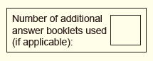**Materials required/recommended for this paper**

This Question/Answer Booklet

Multiple-Choice Answer Sheet

***To be provided by the candidate***

Standard items: pens (blue.black preferred), pencils (including coloured), sharpener, correction fluid/tape, eraser, ruler, highlighters

Special items: nil

**Important note to candidates**

No other items may be taken into the examination room. It is **your** responsibility to ensure that

you do not have any unauthorised notes or other items of a non-personal nature in the

examination room. If you have any unauthorised material with you, hand it to the supervisor

**before** reading any further.

# Structure of this paper

|  |  |  |  |  |  |
| --- | --- | --- | --- | --- | --- |
| Section | Number of questions available | Number of questions to be answered | Suggested working time (minutes) | Percentage of written examination | Marks available |
| Section One Multiple-choice | 20 | 20 | 30 | 20 | 20 |
| Section Two Short answer | 7 | 7 | 90 | 50 | 78 |
| Section Three Extended answer | 3 | 2 | 60 | 30 | 30 |
| **Total** | | | | 100 | 128 |
|  | | | | | % |

**Instructions to candidates**

1. The rules for the conduct of this examination have been outlined. Sitting this examination implies that you agree to abide by these rules.
2. Answer the questions accordint to the following instructions

Section One: Answer **all** questions on the separate Multiple-Choice Answer

Sheet. Use a blue or black pen or a B or 2B pencil.

Section Two: Answer **all** questions.

Answers are to be written in this Question/Answer booklet using blue or black pen or a B or 2B pencil.

Section Three: Answer **two** of the three questions available.

Answers to each question need to be written on the lined paper booklet provided with the question number clearly marked.

1. Supplementary pages (for the use of planning/continuing your answer to a question) have been provided at the end of this Question/answer booklet. If you use these pages to continue an answer, indicate at the original answer where the answer is continued, i.e. give the page number.

**Section One: Multiple-choice 20% (20 marks)**

This section has **20** questions. Answer **all** questions on the separate Multiple-choice answer sheet provided. For each question, shade the box to indicate your answer. Use only blue or black pen to shade the boxes. Do not use erasable or gel pens. If you make a mistake, place a cross through the square, then shade your new answer. Do not erase or use correction fluid/tape. Marks will not be deducted for incorrect answers. No marks will be given if more than one answer is completed for any question.

Suggested working time: 30 minutes

______________________________________________________________________________________

1. General motion can be defined as
2. motion or translation of a body on a straight trajectory/path.
3. motion where the angular rotation of body segments produce linear motion of the body.
4. motion of a body in a curved trajectory/path.
5. motion of a body in a circular or rotational trajectory/path.
6. Year 7 students are learning to throw a discus for the first time. The teacher explains the discus throwing technique and gives students four key phrases to remember whilst performing the technique. The teacher prompts the students with the four key phrases as they go. The teacher is providing the students with:

(a) visual cues

(b) visual and proprioceptive cues

(c) verbal cues

(d) proprioceptive cues.

1. A golfer has accidentally hit the ball into a deep bunker. A bunker is a course hazard consisting of a hole or depression filled with sand. In order to get the ball back onto the fairway (or green) the golfer will need to hit the ball with:

(a) an increased angle of release

(b) a decreased angle of release

(c) an increased height of release

(d) a decreased height of release.

1. There is a relationship said to exist between arousal levels and optimal performance, this can be explained by
2. the Inverted U Hypothesis, which states that performance increases with arousal to a certain point, after which it can cause performance to decline.
3. Nideffer’s Model which states that arousal and performance rely on the ability to attend to relevant cues.
4. the Inverted U Hypothesis, which states that performance decreases with arousal to a certain point, after which it can cause performance to increase.
5. Nideffer’s Model which states that a broad focus will increase arousal to an optimal point, which will result in an increase in performance.
6. A tennis coach is attempting to develop the accuracy of their player’s forehand drive. They place a target area on the court to help the player direct the shot. This is an example of a
7. verbal cue.
8. proprioceptive cue.
9. kinaesthetic cue.
10. visual cue.
11. A 1500m runner started a race on a 400m track. Due to injury they stop after only completing half of the laps. The runner’s displacement and distance would be:
12. 50m; 750m
13. 750m; 750m
14. 750m; 50m
15. 150m;750m.
16. A golf swing is an example of a
17. 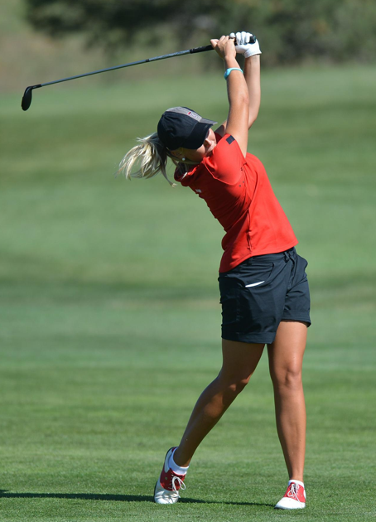discrete skill.
18. serial skill.
19. continuous skill.
20. fine motor skill.
21. Sasha has started going to the gym three times a week and has removed all processed ‘junk’ food from her diet. As a result of these lifestyle changes and positive goal setting, Sasha has increased energy and is feeling happier and healthier than ever. This feeling helps her to stay motivated to continue exercising and eating a healthy diet. This is an example of
22. extrinsic motivation.
23. the zone of optimum functioning.
24. intrinsic motivation.
25. arousal relationship.
26. When the height of release of a projectile is greater than the landing point, the optimal projection or release angle will be
27. greater than 45 degrees.
28. lower than 45 degrees.
29. equal to the height.
30. dependent on the weather conditions.
31. Prior to a game of basketball, a player is feeling nervous and underprepared. Which of the following could they do to ‘get in the zone’?

(a) Listen to calming music.

(b) Think about the previous mistakes they made so they don’t make the same mistake again.

(c) Focus on being the winner.

(d) Listen to advice from the crowd.

1. Which type of attention would be used by a fast bowler considering what delivery to bowl to the batsmen for the next ball?

(a) Broad-external focus

(b) Narrow-internal focus

(c) Broad-internal focus

(d) Narrow-external focus

1. Skills appear on a continuum ranging from open to closed. Which of the following would be considered most ‘closed’?

(a) Receiving a pass in a game of netball

(b) Surfing an open ocean break

(c) Firing an arrow in archery

(d) Receiving a serve in volleyball

1. A gymnast receives immediate internal feedback regarding their balance in a handstand as soon as they execute it. This type of feedback during performance is called
2. verbal feedback.
3. extrinsic feedback.
4. concurrent feedback.
5. terminal feedback.
6. When executing a smash in badminton, the coach encourages the player to contact the shuttle at its highest point. What would be the most relevant rationale behind this instruction?
7. to give the player more time to execute the shot and move into a defensive position quickly
8. to give the player an opportunity to impart greater linear velocity onto the shuttle as a result of greater angular motion at the distal end of the racquet
9. to give the player an opportunity to apply Newton’s third law of motion and create greater distance on the shuttle
10. to trick the opposition into thinking the player is going to do a drop shot instead of a smash to easily win the point
11. Negative acceleration is when:

(a) A person is moving backwards

(b) Velocity is decreasing

(c) Velocity is increasing

(d) Velocity is constant

1. A baseball pitcher aims to pitch the ball with maximum velocity. To achieve this they should use:

(a) Sequential movement

(b) Simultaneous movement

(c) Static movement

(d) Single movement

1. To assist coaches in teaching skilled movement, motor skills are classified according to their characteristics. An “open” skill is where an athletes sensory environment is:

(a) Static and controlled

(b) Constantly changing

(c) Too challenging

(d) Simple rather than complex

1. Compared to a novice performer, the optimum arousal zone for an elite athlete occurs when arousal is:

(a) Higher

(b) Lower

(c) The same

(d) Not comparable

1. The aim of javelin throw is to maximise distance. Throwers achieve this by applying maximum force over the longest period of time. This can be achieved through
2. perfectly timed simultaneous movement
3. keeping the centre of gravity within the base of support
4. perfectly timed sequential movement
5. increasing rotational inertia
6. Goal setting is an important process in performance and maintaining motivation. Young, novice performers would most likely benefit from
7. staying focused on outcome goals only
8. setting ambitious long-term goals to maintain motivation
9. setting realistic short-term goals which are reviewed regularly
10. working on the same goals for the duration of the season

**End of Section One**

**Section Two: Short answer 50% (78 marks)**

This section has **seven** questions. Answer **all** questions. Write your answers in the space provided.

Use blue or black pen (**not** pencil) for this section.

Supplementary pages for planning/continuing your answers to questions are provided at the end of this Question/Answer booklet. If you use these pages to continue an answer, indicate at the original answer where the answer is continued, i.e. give the page number.

Suggested working time: 70 minutes.

______________________________________________________________________________________

**Question 21 11 marks**

The photographs below show two different techniques of headstand. The biomechanical principle of balance is crucial when performing these postures.

1. Compare the two headstand techniques with reference to two factors that enable stability to be maintained. Identify which headstand would be easier to perform and provide a reason. (4 marks)

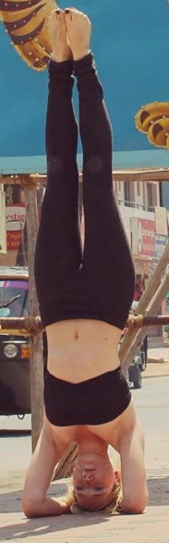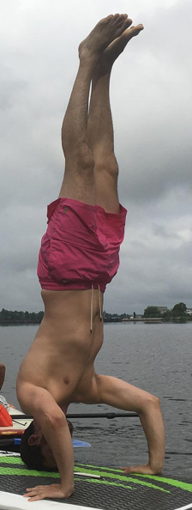

**Headstand A**  **Headstand B**

__________________________________________________________________________________________________________________________________________________________________________________________________________________________________________________________________________________________________________________________________________________________________________________________________________________________________________________________________________________________________________________________________________________________________________________________________________________________

1. Executing a headstand requires focus and concentration. One model that explains attentional focus is Nideffer’s Model of Attention. Complete the diagram below to include
2. labels for axis A and B
3. labels for the four attentional styles (C, D, E and F)
4. Indicate (with a label) the position of the attentional style most suitable for the headstand

(7 marks)

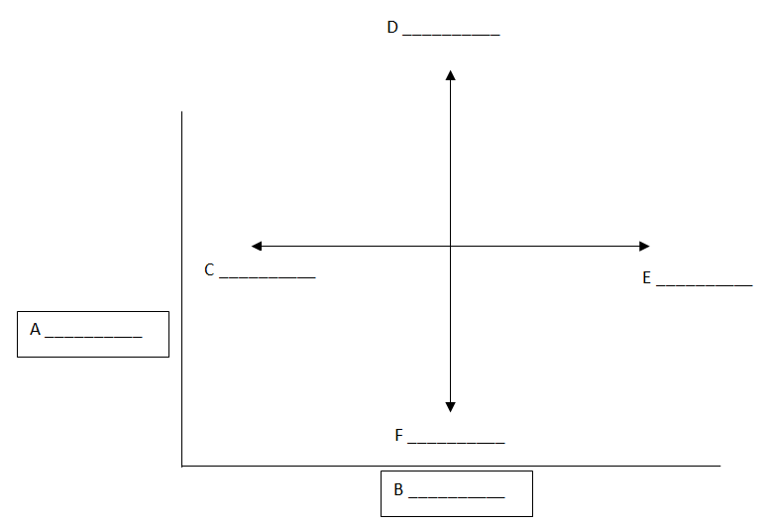

Suitable attention styles for a headstand _________________________________________

**Question 22 6 marks**

The ‘bend back’ is a gymnastic movement which requires a significant amount of flexibility and strength to perform well.

1. Using the picture below, identify and draw the location of the gymnasts ‘Centre of Gravity’ as well as the ‘Line of Gravity’ (2 Marks)



1. Human beings do not remain fixed in the anatomical position and therefore the precise location of the Centre of Gravity changes constantly with every new position of the body and limbs, including ‘Bend backs’. Discuss this statement and make reference to the above picture. (4 Marks)

________________________________________________________________________________________________________________________________________________________________________________________________________________________________________________________________________________________________________________________________________________________________________________________________________________________________________________________________________________________________________________________________________________________________________________________________________________________________________________________________________________________________________________

**Question 23 11 marks**

A gymnastic coach encourages their gymnast to increase their height of release by using a mini trampoline when learning a somersault.

1. With reference to optimal projection, explain the rationale behind this recommendation by the coach and why it may be of benefit to the gymnast. (3 marks)

________________________________________________________________________________________________________________________________________________________________________________________________________________________________________________________________________________________________________________________________________________________

1. Apart from height of release. Name and define the **two** other factors that contribute to the flight path (parabolic trajectory) of a projectile, which would also be considered by the coach. (4 marks)

____________________________________________________________________________________________________________________________________________________________________________________________________________________________________________________________________________________________________________________________________________________________________________________________________________________________________________________________________________________________________________________________________

1. The gymnast struggles with pre-competition nerves each time they get ready to perform their floor routine. The impact of stress and nerves negatively affects their physical performance and self-confidence.

Name **two** of the most relevant mental skills strategies which this gymnast could use pre-performance to

1. decrease the physical symptoms of nerves e.g. shaking
2. increase self-confidence prior to performance.

For **each** strategy provide a relevant example of how the gymnast could apply this technique. (4 marks)

______________________________________________________________________________________________________________________________________________________________________________________________________________________________________________________________________________________________________________________________________________________________________________________________________________________________________________

____________________________________________________________________________________________________________________________________________________________________________

**Question 24 12 marks**

When getting ready to receive a serve in tennis, a player is processing a considerable amount of information in preparing to perform the skill.

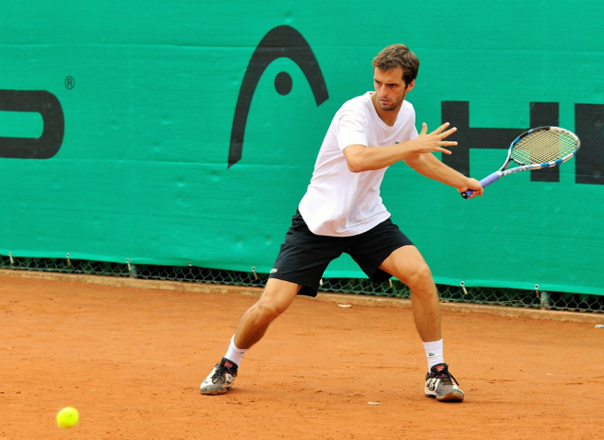

1. Draw and label a diagram in the space below which represents the **four** phases of information processing that could be used to explain the process that the tennis player is experiencing when receiving a serve. (4 marks)
2. Outline each phase, and describe **one** example which could be applied to the tennis player receiving the serve. (8 marks)

________________________________________________________________________________________________________________________________________________________________________________________________________________________________________________________________________________________________________________________________________________________________________________________________________________________________________________________________________________________________________________________________________________________________________________________________________________________________________________________________________________________________________________

____________________________________________________________________________________________________________________________________________________________________________

**Question 25 22 marks**

In building foot speed to kick the ball, the hip, knee and ankle are used.



1. Classify what type of movement this is from the coordination continuum. (1 mark)

___________________________________________________________________________

1. On the graph below, draw and label the optimal timing of the action of the hip, knee and ankle joints for maximum foot velocity, when kicking the ball. (3 marks)

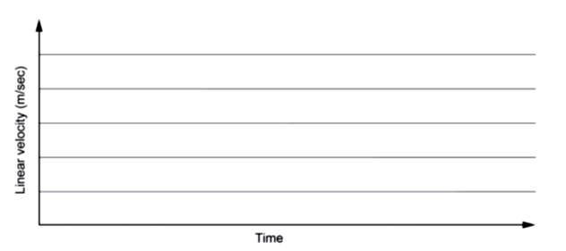

1. Describe two biomechanical factors that would maximise the velocity of impact with the ball. (4 marks)

________________________________________________________________________________________________________________________________________________________________________________________________________________________________________________________________________________________________________________________________________________________________________________________________________________________________________________________________________________________________________________________________________________________________________________________________________________________________________________________________________________________________________________

1. Describe the two different types of balance utilised in sport and explain which type of balance is required to kick the ball (5 marks)

____________________________________________________________________________________________________________________________________________________________________________________________________________________________________________________________________________________________________________________________________________________________________________________________________________________________________________________________________________________________________________________________________

____________________________________________________________________________________________________________________________________________________________________________

(e) The footballer tells you that he has been using imagery to improve goal kicking. But he says it has made him worse at set shots. Having asked what does he imagine, he says: “when I am running in to kick at goal, I mentally rehearse and see how I don’t want things to go, then I imagine a good kick while I am kicking it”. What advice do you have for Jack on his use of imagery? (3 marks)

____________________________________________________________________________________________________________________________________________________________________________________________________________________________________________________________________________________________________________________________________________________________________________________________________________________________________________________________________________________________________________________________________

____________________________________________________________________________________________________________________________________________________________________________

An AFL player needs to be proficient in many skills to be considered a great player. They must able to pass the ball effectively to a team mate using both a handball and a kick.

1. The ball can take many different paths as it flies through the air during a game. For each trajectory describe one benefit and give an example of when this trajectory would likely occur in an AFL game.

(6 marks)

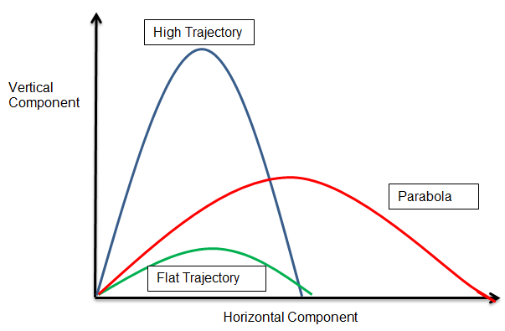

____________________________________________________________________________________________________________________________________________________________________________________________________________________________________________________________________________________________________________________________________________________________________________________________________________________________________________________________________________________________________________________________________

____________________________________________________________________________________________________________________________________________________________________________

____________________________________________________________________________________________________________________________________________________________________________________________________________________________________________________________________________________________________________________________________________________________________________________________________________________________________________________________________________________________________________________________________

____________________________________________________________________________________________________________________________________________________________________________

______________________________________________________________________________________

____________________________________________________________________________________________________________________________________________________________________________

**Question 26 6 marks**

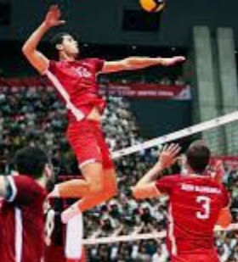

1. Professional Volleyball player Matey Kaziyski of Bulgaria, on average, will spike the ball at 130km/h. Explain Newtons 1st and 2nd laws of motion as applied on the above picture of a spike. (4 marks)

__________________________________________________________________________________________________________________________________________________________________________________________________________________________________________________________________________________________________________________________________________________________________________________________________________________________________________________________________________________________________________________________________________________________________________________________________________________________________________________________________________________________________________________________________________________________________________________________________________________________________________________________________________________________________________________________________________________________________________________

(b) Explain what is meant when an athlete says they are ‘in the zone’. (2 marks)

________________________________________________________________________________________________________________________________________________________________________________________________________________________________________________________________________________________________________________________________________________________

**Question 27 10 marks**

A Tennis coach aims to develop his students skills and game play.

1. He uses feedback regularly as he is teaching his students. Describe the three purposes of feedback and give an example of each that the tennis coach may use with his students (6 marks)

__________________________________________________________________________________________________________________________________________________________________________________________________________________________________________________________________________________________________________________________________________________________________________________________________________________________________________________________________________________________________________________________________________________________________________________________________________________________________________________________________________________________________________________________________________________________________________________________________________________________________________________________________________________________________________________________________________________________________________________

1. With the exception of linear motion, describe two other types of motion occurring in a tennis match and provide one example for each. (4 marks)

________________________________________________________________________________________________________________________________________________________________________________________________________________________________________________________________________________________________________________________________________________________________________________________________________________________________________________________________________________________________________________________________________________________________________________________________________________________________________________________________________________________________________________

**End of Section Two**

**Section Three: Extended answer 30% (30 marks)**

This section contains **three** questions. You must answer **two** questions. Write your answer in the spaces provided.

Supplementary pages for planning/continuing your answers to questions are provided at the end of this Question/ Answer booklet. If you use these pages to continue an answer, indicate at the original answer where the answer is continued, i/e. give the page number.

Suggested working time: 50 minutes

______________________________________________________________________________________

**Question 28 15 marks**

The ‘Tour De France’ is one of the world’s most famous cycling events. It takes place annually in France and consists of 21 day-long segments, (stages) covering approximately 3500km.

1. Riders of the ‘Tour De France use bicycles made of carbon fibre as they are extremely lightweight compared to an aluminium frame. Identify and define the appropriate Newton’s Law then explain why cyclists would benefit from using a bicycle that has a very light frame. (4 marks)

__________________________________________________________________________________________________________________________________________________________________________________________________________________________________________________________________________________________________________________________________________________________________________________________________________________________________________________________________________________________________________________________________________________________________________________________________________________________________________________________________________________________________________________________________________________________________

1. The ‘Tour De France’ is an extremely challenging event, both physically and mentally. Riders continually push their bodies to the limit over 21 days. Being able to cope with mental issues plays an important role in the rider’s success. Outline the five mental strategies the rider could use to manage mental issues ad identify which of these might be the most important for a first time rider of the race (11 marks)

__________________________________________________________________________________________________________________________________________________________________________________________________________________________________________________________________________________________________________________________________________________________________________________________________________________________________________________________________________________________________________________________________________________________________________________________________________________________________________________________________________________________________________________________________________________________________________________________________________________________________________________________________________________________________________________________________________________________________________________________________________________________________________________________________________________________________________________________________________________________________________________________________________________________________________________________________________________________________________________________________________________________________________________________________________________________________________________________________________________________________________________________________________________________________________________________________________________________________________________________________________________________________________________________________________________________________________________________________________________________________________________________________________________________________________________________________________________________________________________________________________________________________________________________________________________________________________________________________________________________________________________________________________________________________________________________________________________________________________________________________________________________________________________________________________________________________________________________________________________________________________________________________________________________________________________________________________________________________________________________________________________________________________________________________________________________________________________________________________________________________________________________________________________________________________________________________________________________________________________________________________________________________________________________________________________________________________________________________________________________________________________________________________________________________________________________________________________________________________________________________________________________________________________________________________________________________________________________________________________________________________________________________________________________________________________________________________________________________________________________________________________________________________________________________________________________________________________________________________________________________________________

**Question 29 15 marks**

The photograph below shows a highly skilled basketball player on a fast break down the court. The player is proficient in executing the skill of dribbling, whilst being able to attend to additional cues surrounding him during the game.

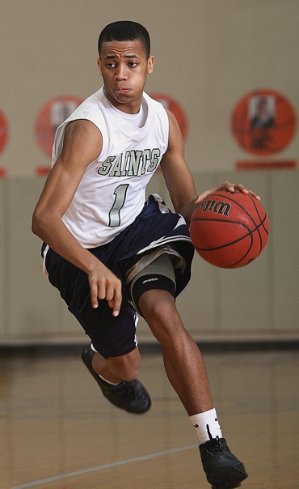

Aware of his teammates

Proficient dribbling skills

Aware of the opposing team

Name and outline the **three** phases of the Fitts and Posner Model of motor learning that this player would have progressed through to reach his current level of proficiency. State **two** performance characteristics which would be evident at each stage of learning and outline the type of feedback which would optimise learning at each stage. (15 marks)

__________________________________________________________________________________________________________________________________________________________________________________________________________________________________________________________________________________________________________________________________________________________________________________________________________________________________________________________________________________________________________________________________________________________________________________________________________________________________________________________________________________________________________________________________________________________________________________________________________________________________________________________________________________________________________________________________________________________________________________________________________________________________________________________________________________________________________________________________________________________________________________________________________________________________________________________________________________________________________________________________________________________________________________________________________________________________________________________________________________________________________________________________________________________________________________________________________________________________________________________________________________________________________________________________________________________________________________________________________________________________________________________________________________________________________________________________________________________________________________________________________________________________________________________________________________________________________________________________________________________________________________________________________________________________________________________________________________________________________________________________________________________________________________________________________________________________________________________________________________________________________________________________________________________________________________________________________________________________________________________________________________________________________________________________________________________________________________________________________________________________________________________________________________________________________________________________________________________________________________________________________________________________________________________________________________________________________________________________________________________________________________________________________________________________________________________________________________________________________________________________________________________________________________________________________________________________________________________________________________________________________________________________________________________________________________________________________________________________________________________________________________________________________________________________________________________________________________________________________________________________________________________________________________________________________________________________________________________________________________________________________________________________________________________________________________________________________________________________________________________________________________________________________________________________________________________________________________________________________________________________________________________________________________________________________________________________________________________________________________________________________________________________________________________________

**Question 30 15 marks**

A high jumper changes their movement during the approach phase from a horizontal motion to a vertical motion by applying a greater downward force on the last step before take-off. The rationale behind force application can be linked to Newton’s First, Second and Third Law of motion.

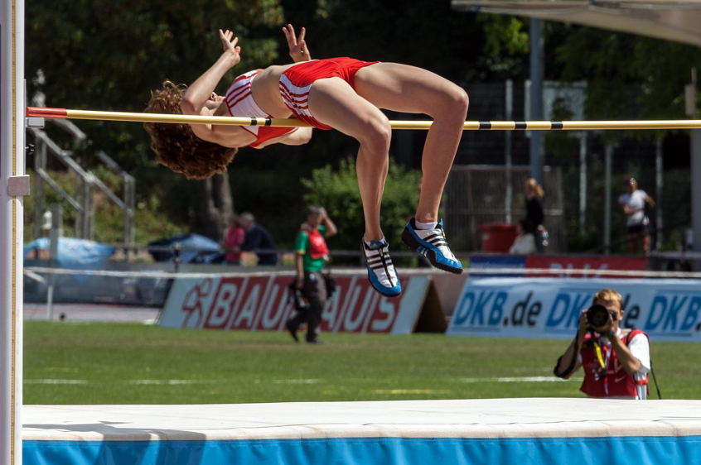

1. Define Newton’s First, Second and Third Law. With reference to the Newton’s First and Third law, explain how each law can be applied to the high jumper during run-up and take off. (7 marks)

________________________________________________________________________________________________________________________________________________________________________________________________________________________________________________________________________________________________________________________________________________________________________________________________________________________________________________________________________________________________________________________________________________________________________________________________________________________________________________________________________________________________________________________________________________________________________________________________________________________________________________________________________________________________________________________________________________________________________________________________________________________________________________________________________________________________________________________________________________________________________________________________________________________________________________________________________________________________________________________________________________________________________________________________________________________________

1. Arousal levels during performance are an important component in sporting competitions. High jump competitors often have to wait for long periods of time between jumps, which can affect arousal regulation and performance levels.

Name and explain the relationship between arousal and performance, draw and label a diagram to support your discussion, indicating the point of optimal arousal for the high jumper. (8 marks)

__________________________________________________________________________________________________________________________________________________________________________________________________________________________________________________________________________________________________________________________________________________________________________________________________________________________________________________________________________________________________________________________________________________________________________________________________________________________________________________________________________________________________________________________________________________________________________________________________________________________________________________________________________________________________________________________________________________________________________________________________________________________________________________________________________________________________________________________________________________________________________________________________________________________________________________________________________________________________________________________________________________________________________________________________________________________________________________________________________________________________________________________________________________________________________________________________________________________________________________________________________________________________________________________________________________________________________________________________________________________________________________________________________________________________________________________________________________________________________________________________________________________________________________________________________________________________________________________________________________________________________________________________________________________________________________________________________________________________________________________________________________________________________________________________________________

**End of questions**